GRADE: XII APPROXIMATIONS

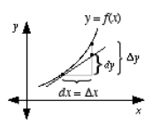
We use differentiation to find the approximate values of the certain quantities. If there is a very small change in one variable correspond to the other variable then we use the differentiation to find the approximate value.
The differentiation of x is represented by dx is defined by dx = x where x is the minor change in x.
The differential of y is represented by dy is defined by dy = (dy/dx) x.
As x is very small compared to x, so dy is the approximation of y. hence dy = y.
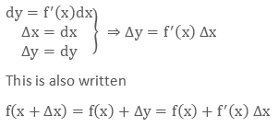
This shows that the derivative of the dependent variable is not equal to the increase of the variable whereas the derivative of independent variable is equal to the increase of the variable.
Example
Find the approximate value of √26.
Solution
Here it is very easy to find the value of under root if the given number is perfect square but for such type of numbers we have to use the derivatives to find the approximate value of the function.
Let the f(x) =√x and the derivative of this is
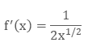
Now we know the formula of approximation
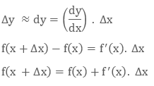
Here we will assume x near to 26 which is a perfect square.
So we will assume
x = 25
x₂ – x₁= 26 – 25 = 1
Here tells us the change in x.
Let x = 25 and
Now we will put the values in the formula
